**Introduction**

Although most people still live in urban areas of Canada, which are close to the border of the United States or along Lake Ontario, rural areas comprise the vast majority of Canada’s landmass[1]. Therefore, understanding the rural business performance is very important. It not only relates to the growth of population in the rural areas but also can provide some information regarding migration and development trends.

From 2016 to 2021, the rural population has increased to 6.6 million, a 0.4% growth. However, the share of the population living in rural areas decreased from 18.7% in 2016 to 17.8% in 2021[2]. Although more people live in rural areas nowadays, most people still prefer urban cities. Thus, it is meaningful to analyze the rural business performance from 2016 to 2019 to see if population growth would help them or not.

The analysis is supported by Rural Canada Business Profile, which collects information related to small and medium businesses from 2016 to 2019. In this dataset, small businesses are those whose annual revenue are between $30,000 and $5,000,000, while medium businesses are those whose annual revenue are between $5,000,001 to $20,000,000. The analysis investigates several dimensions, which includes revenues, profit, expense and financial ratios.

**Highlights**

**Revenue/Profit:**

**Expense:** For both rural and urban areas, medium businesses and small businesses had opposite distribution for their expenses. Direct expenses was the major cost of medium businesses, while small businesses had their majority of expenses on indirect aspects.

**Liquidity/Solvency:** The small rural business has both lower current debt to equity and debt to equity ratio in contrast to medium rural business, which means it has a better liquidity and solvency. Medium and small rural businesses have different industries facing liquidity and solvency problems.

**Return on Investment:** Medium businesses had better ability to generate cash and make profit on the same amount of investment. In addition, small businesses in rural areas performed better than those in urban areas in terms of profitability.

**Methodology**

This analysis uses Statistics Canada’s Rural Canada Business Profiles (RCBP) database, which is based on business tax returns filed with the Canada Revenue Agency[3]. In order to make visualizations and analyze the data, we convert the data into a data frame and use pandas to do data cleaning and wrangling.

For the data cleaning and wrangling part, we filter out the incomplete rows and replace the missing value with zero. We combine the data from 2017 to 2019 together to analyze the data year by year. And we select the columns that are relevant to our visualizations and analysis.

We use Python Altair and Tableau to make the visualizations. The first 12 visualizations are made by Python Altair and the rest 11 visualizations are made by Tableau.

**Definition[4]**

Database General Concept:

* Using Statistics Canada’s Standard Geographical Classification (SGC) 2016,
* businesses located in either census metropolitan areas (CMAs) or census agglomerations (CAs) are classified as “urban” and all others as “rural”.
* Small businesses are defined as those businesses that have annual revenues of $30,000 to $5,000,000; this group includes incorporated and unincorporated businesses.
* Medium businesses are defined as those having annual revenues of $5,000,001 to $20,000,000. All medium businesses are incorporated.
* An unincorporated business is typically a sole proprietorship or partnership where the owner(s) and the business are the same, and the owner(s) bear all results of the business.
* An incorporated business is a separate entity from the owner(s).
* Industries are defined using the North American Industry Classification System (NAICS).

Revenue:

* Sales of goods and services indicates the revenue from the sales of goods and services.
* All other revenues indicate revenue from interest, dividends, commissions, rent and other sources of revenue.
* Total revenue indicates revenue from the sale of goods and services, interest, dividends, commissions, rent and other sources of revenue. It excludes capital gains or losses, extraordinary gains or losses and equity in net income of related parties.

Profit/Loss:

* Profitable businesses are businesses for which revenue is equal to or exceeds expenses during the reference period.
* Non-profitable businesses are businesses for which expenses exceed revenue.

Expense:

* Cost of sales (direct expenses): This category includes direct costs incurred by businesses from the process of selling goods. This item is calculated as wages and benefits + purchases, materials and subcontracts + opening inventory - closing inventory.
* Operating expenses (indirect expenses): This category includes all expenses incurred in the course of running the business. It includes remuneration paid as labour and commissions, amortization and depletion, repair and maintenance costs, utility fees and telephone and telecommunication fees, rent, interest and bank fees, professional and business fees, advertising and promotional costs, delivery fees and shipping and warehouse expenses, insurance costs, and other indirect expenses.

Financial Ratios:

* Gross Margin is calculated as (sales of goods and services - costs of sales * 100) / (sales of goods and services). This percentage provides a relative measure of the profitability or profit margin.
* Net profit to equity is calculated as (net profit * 100) / (equity). This percentage indicates the profitability of a business. It relates the business income to the amount of investment committed to earning that income. This percentage is also known as “return on investment” or “return on equity.” The higher the ratio, the relatively better the profitability.
* Revenue to equity ratio is calculated as (total revenue) / (equity). It indicates the profitability of a business, relating the total business revenue to the amount of investment incurred to earn this income. This ratio provides an indication of the economic productivity of capital.
* The current debt to equity is calculated as (current liabilities)*100%/(equity). It is a measure of liquidity, which indicates a firm's relative ability to pay its short-term debts. The lower the positive ratio, the more liquid the business.
* The debt to equity ratio is calculated as total liabilities/total equity, it is a solvency ratio that indicates a firm's ability to pay its long-term debts. The lower the positive ratio, the more solvent the business.

**Revenue:**

**Agriculture, forestry, fishing and hunting, and professional, scientific and technical services were one of the top 5 industries in rural and urban respectively while performing badly in opposite in terms of the total number and total revenue of medium businesses.**

The total number and the total revenue across different industries in rural and urban areas had very similar distribution structures between 2017 and 2019. The industry ranks in the total number and the total revenue of medium businesses are basically the same to each other. This indicates the numbers of the businesses in different industries were of great influence on their total revenues.

The top 5 main industries (cite client paper) in rural and urban medium businesses both kept their positions in their ranks of both the total number and the total revenue. Amongst them retail trade, construction, manufacturing, and wholesale trade are among the top 5 industries in both rural and urban. However, agriculture, forestry, fishing and hunting took the top second position in rural, while ranked about the bottom 5th in urban; professional, scientific and technical services took the last position of the top 5, while ranked about bottom 6th in rural(Chart 1).

**Chart 1: Total number and total revenue of businesses, medium businesses, Canada, by industry and rural and urban areas, 2017-2019**

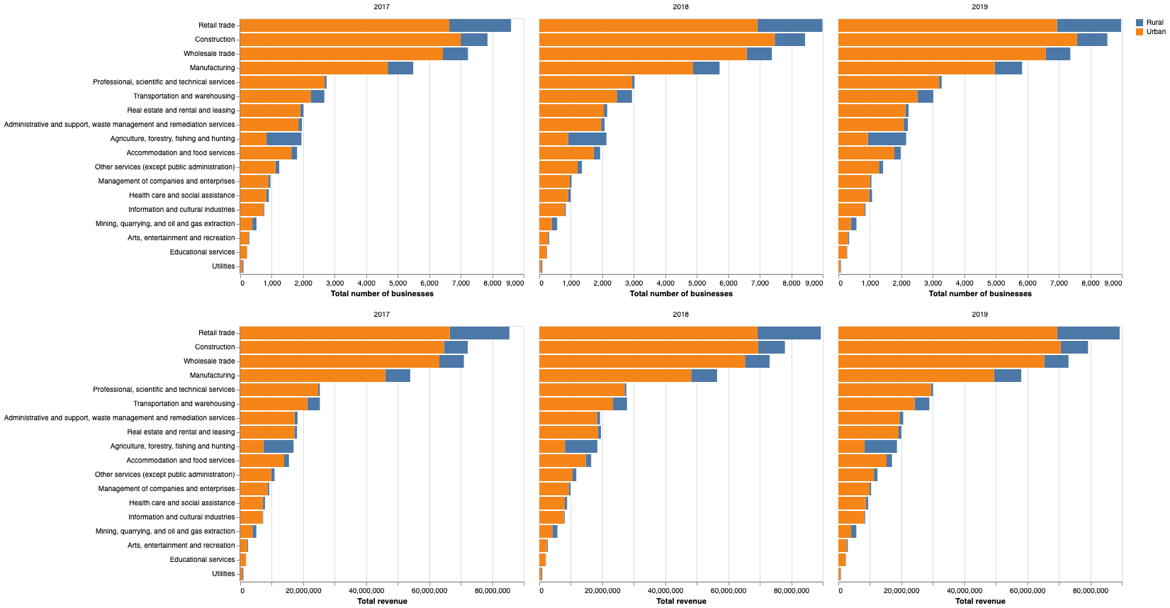

**Management of companies and enterprises had the highest industry average revenue in rural medium businesses in 2019, while its percent of average sales of goods and services to average revenue ranked the bottom in both rural and urban.**

The distribution of average revenue in different industries varied mildly both in rural and urban medium businesses from 2017 to 2019. The total revenue of Management of companies and enterprises only accounted for 0.7% in the total revenue (0.6% in the total number of businesses) in rural and 2.4% (2.3% in the total number of businesses) in urban, but its average revenue ranked the first in rural in 2019 which is 1.13 times of the rural all industry average revenue (this number is 1.04 times in urban). Meantime the percentage of average sales of goods and services to average revenue in Management of companies and enterprises ranked the bottom in both rural and urban, but it is much lower in urban which is 21.7% than that in rural which is 39.6%(Chart 2).

**Chart 2: Average revenue and sales of goods and services (percent of total revenue), medium businesses, Canada, by industry and rural and urban areas, 2017-2019**

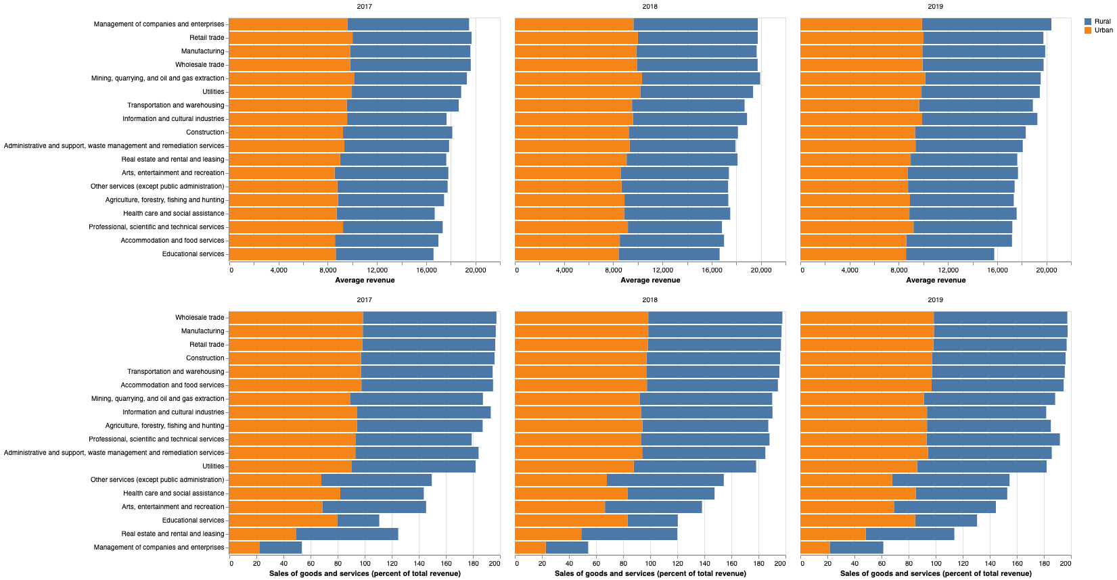

**Agriculture, forestry, fishing and hunting had the greatest number of small businesses in rural areas, and construction and real estate and rental and leasing came next in 2019.**

Agriculture, forestry, fishing and hunting, construction and real estate and rental and leasing were the top 3 industries in the number of small businesses in rural areas. Wherein, agriculture, forestry, fishing and hunting had the greatest number in incorporated small businesses, while real estate and rental and leasing had the greatest number in unincorporated small businesses. Compared to its counterpart of urban, except construction and real estate and rental and leasing, professional, scientific and technical services came second in its top 3 industries in total number of businesses(Chart3). The top 3 industries in total number of businesses in rural and urban mathed their total revenue ranks (cite client paper).

**Except for Ontario, Québec and British Columbia, Prairies had the greatest number of small businesses, Atlantic came next and the last is territories in both rural and urban in 2019.**

Québec had the greatest number of small businesses (78,956) in rural areas and Ontario(66,376) came next in 2019. Alberta ranked third place(52,748) in the total number of small businesses, and then British Columbia(34,622) in rural 2019. This order had a little bit change in urban that Ontario had the greatest number of small businesses (707,592), Québec with 357,146 small businesses came second, British Columbia came third (298417)and Alberta had the fourth greatest number of small businesses(215,904). Overall, in 2019 Prairies, Atlantic and Territories had 92,672, 38,391, 1,435 small businesses respectively in rural areas.

**Chart 3: Total number of businesses, small businesses, Canada, by industry and provinces/territories and rural and urban areas, 2017-2019**

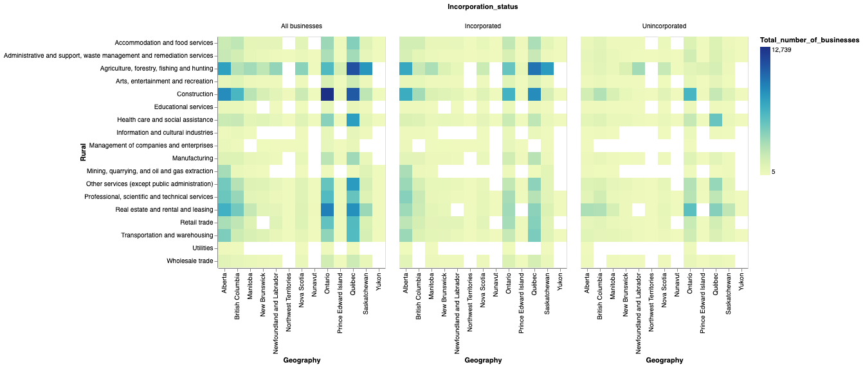

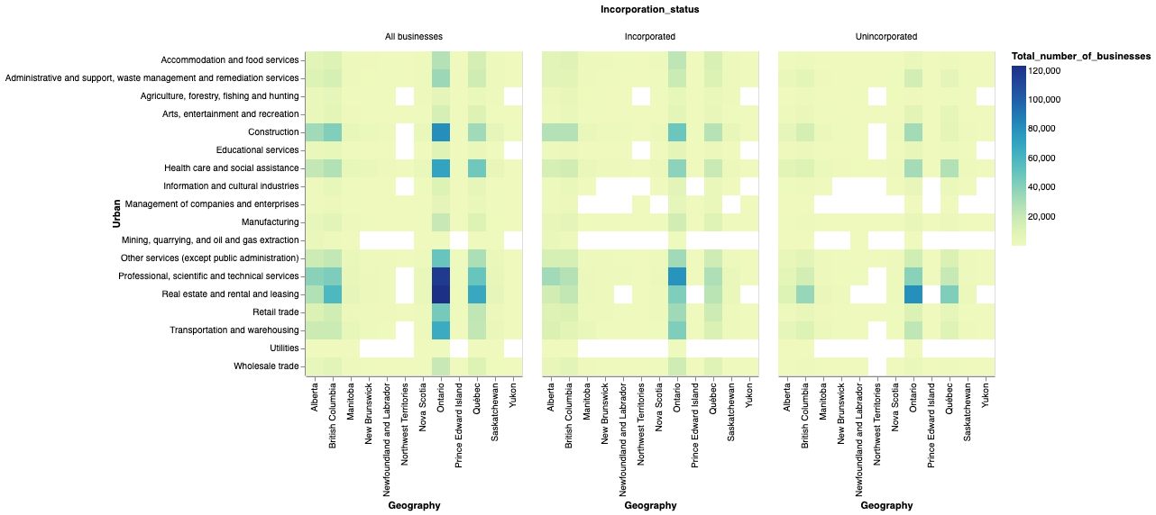

**Profit and loss:**

**Health care and social assistance, management of companies and enterprises and professional, scientific and technical services took up the top 3 in the percent of profitable small businesses, while Agriculture, forestry, fishing and hunting had the lowest percent of profitable small businesses in both rural and urban in 2019.**

The percentage of profitable small businesses in rural areas had slightly decreased from 2017 to 2019 and were lower than that in urban areas. The percentage of profitable small businesses in rural areas was 76.3% in 2017, 76.1% in 2018, and 75.6% in 2019. The corresponding number in urban areas was 81.7%, 81.8% and 81.4% (Chart 4). Health care and social assistance had the highest percent of profitable small businesses in both rural and urban (over 90%); Management of companies and enterprises, professional, scientific and technical services had the second and third highest percent of profitable businesses(both over 85%) in both rural and urban. Agriculture, forestry, fishing and hunting had the lowest percent of profitable businesses in both rural(51.5%) and urban(53.9%)(Chart 5).

**Chart 4: The percent of profitable businesses, small businesses, Canada, by rural and urban areas, 2017-2019**

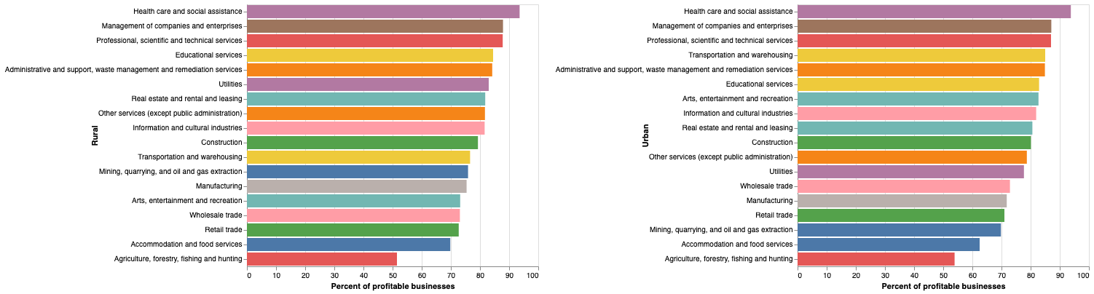

**Chart 5: The percent of profitable businesses, small businesses, Canada, by industry and rural and urban areas, 2019**

**Expense:**

**Medium businesses in rural area and urban area had similar average total expenses**

From 2017 to 2019, the average total expenses of medium businesses in both rural and urban areas did not have significant changes. The average total expenses for rural medium businesses increased by 76.8K from 8896.5K in 2017 to 8973.3K in 2019, while for urban medium businesses, this value decreased by 20.6K from 8893.6K in 2017 to 8873K in 2019 (Chart 1 left). The changed values were less than 1% of their average total expenses values.

Compared with urban businesses, rural businesses have higher total expenses as a percentage of their total revenues. For rural businesses, the percentage values were 96.1%, 96.2%, 96.4% in 2017, 2018, 2019 respectively. The corresponding values for urban businesses were 93.6%, 92.9%, 92.9% (Chart 1 right). The total expenses percentage of rural businesses increased 0.3%, while the total expenses percentage of urban businesses decreased 0.7%. Although there are slight changes on total expenses value, the urban businesses seemed to have slightly better performance on expenses control.

**Chart 1**

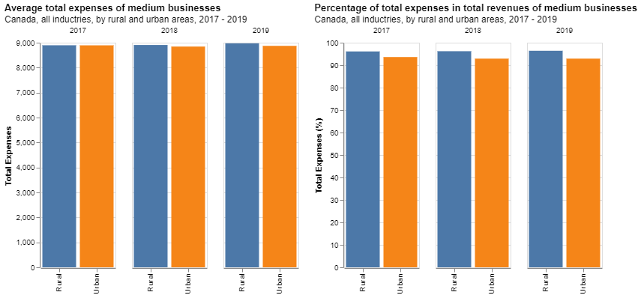

**The average total expenses of small businesses in rural areas was higher than small businesses in urban areas**

As shown in the chart 2, in these 3 years from 2017 to 2019, whatever incorporation status was, the average total expenses of small rural businesses were always larger than small urban businesses. For example, In 2019, average total expenses of small rural businesses were 606.8K for incorporated businesses and 89.2K for unincorporated businesses, which were higher than the corresponding values of small urban businesses (504.9K for incorporated businesses and 65.9K for unincorporated businesses) (Chart 2). The value for incorporated businesses was much higher than unincorporated businesses, while the rural businesses had higher value than urban businesses. Over these three years, the average total expenses for all rural small businesses was 412.8K, while for urban medium businesses, this value was about 339.6K.

Compared with urban businesses, rural businesses also had higher total expenses as a percentage of their total revenues. In recorded 3 years (2017,2018,2019), the total expenses percentage of all rural businesses increased 1.1% (from 92.5% to 93.6%), while the total expenses percentage of all urban businesses increased 0.5% (from 85.4% 85.9%).

**Chart 2**

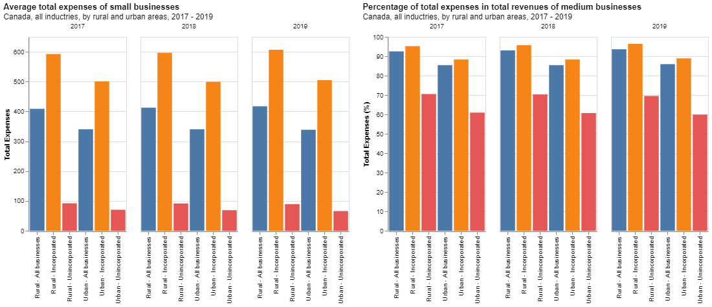

**The distribution of expenses was different for medium and small businesses**

For medium rural businesses in recorded 3 years, the average direct expenses was 5411.06K which was larger than the average indirect expenses (3514.7K). For medium urban businesses, between 2017 and 2019, the average direct expenses (5583.8K) was also larger than the average indirect expenses (3286.5K) (Chart 3). For direct expenses, average expenses values of medium businesses in rural areas was lower than urban areas, while for indirect expenses, average expenses values of medium businesses in rural areas was higher than urban areas.

**Chart 3**

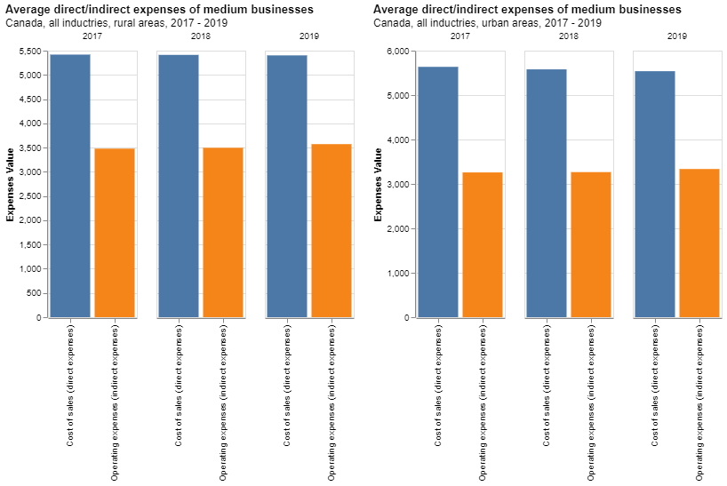

For small rural businesses in recorded 3 years, the average direct expenses was 144.1K which was lower than the average indirect expenses (268.7K). For urban businesses, between 2017 and 2019, the average direct expenses (137.2K) was also lower than the average indirect expenses (202.3K) (Chart 4). Whatever expenses types are, average expenses values of businesses in rural areas are always larger than urban areas.

**Chart 4**

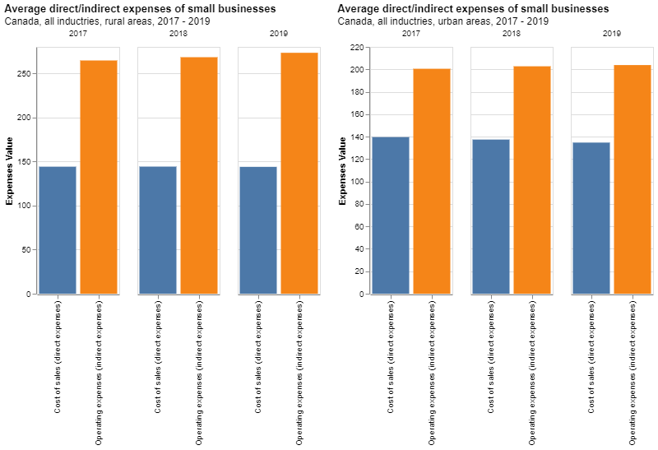

For both rural and urban areas, medium businesses and small businesses had opposite distribution for their expenses. Direct expenses was the major cost of medium businesses, while small businesses had their majority of expenses on indirect aspects.

**Top 2 types of expenses accounted for more than half of the medium business total expenses**

The distribution of medium business expenses among expenses types was similar in the three years from 2017 to 2019, but it was different in rural and urban areas.

In 2019, rural areas, 'Purchases, materials and sub-contracts' (43.89%), 'Other indirect expenses' (12.88%) were top 2 expenses types, which accounted for more than half (56.77%) of rural medium business expenses. For urban areas, 'Purchases, materials and sub-contracts' (44.38%), 'Labour and commissions' (12.57%) were top 2 expenses types that accounted for 56.95% of expenses in total (Chart 5). The 'Purchases, materials and sub-contracts' major expenses type for both rural and urban businesses. Compared to the rural businesses, urban businesses spend more on 'Labour and commissions'.

Furthermore,regardless of the location of businesses (both rural and urban), the opening inventory was slightly smaller than closing inventory in 2019, which might mean that the supply exceeded demand.

**Chart 5**

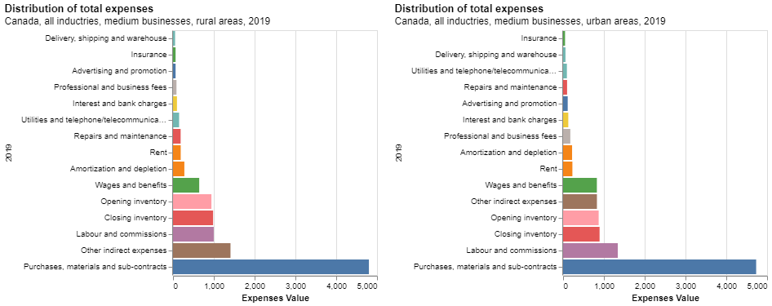

**More than 60% of small business expenses came from 3 types of cost**

The distribution of small business expenses among expenses types was also similar in the three years from 2017 to 2019, but it was different in rural and urban areas.

In 2019, rural area, 'Purchases, materials and sub-contracts' (25.94%), 'Other indirect expenses' (21.11%), 'Labour and commissions' (14.63%) were top 3 expenses types, which accounted for more than half (61.68%) of rural small business expenses, while 'Delivery, shipping and ware hourse' (0.38%) was the least expenses type (Chart 6 left).

For urban area, 'Purchases, materials and sub-contracts' (28.93%), 'Labour and commissions' (19.08%), 'Other indirect expenses' (12.36%) were still top 3 expenses types that accounted 60.37% expenses in total, while 'Insurance' (0.38%) was the least expenses type (Chart 6 right).

**Chart 6**

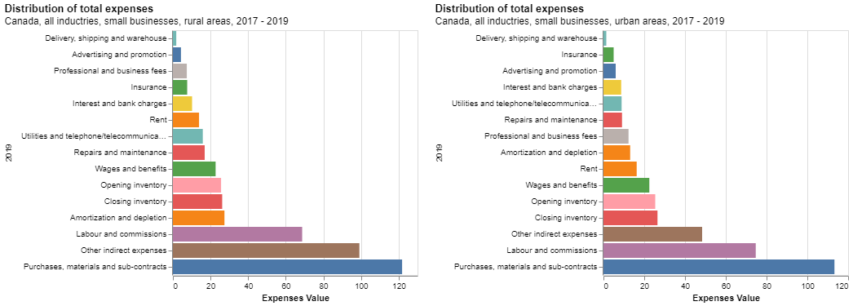

**Average total expenses of industries were similar for medium businesses**

In 2019, 'Wholesale trade' (9561.7K), 'Retail trade' (9514.3K), 'Agriculture, forestry, fishing and hunting' (9494.7K) were the top 3 industries that had most expenses in rural areas.

For businesses in urban areas, the top 3 industries that had the most total expenses were 'Mining, quarrying, and oil and gas extraction', 'Agriculture, forestry, fishing and hunting' and 'Retail trade'. They had 11699.0K, 10177.2K, 9801.5K total expenses respectively.

Through the Chart 7, a fact can be found that Industry shares of total expenses were similar for most medium business industries, while the 'Management of companies and enterprises' industry was significantly smaller than others.

**Chart 7**

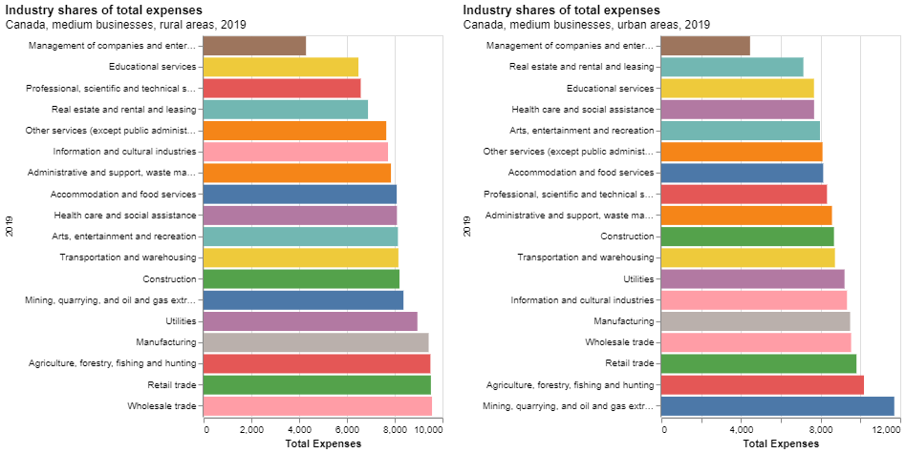

**The differences of industry shares were more obvious for small businesses**

For rural small businesses in 2019, 'Retail trade' (814.6K), 'Agriculture, forestry, fishing and hunting' (735.1K), 'Wholesale trade' (814.6K) were the top 3 industries, which had the most expenses.

For urban small businesses in 2019, 'Mining, quarrying, and oil and gas extraction' (857.5K), 'Wholesale trade' (811.3K), 'Manufacturing' (725.5K) were the top 3 industries, which had the most expenses.

Compared to medium businesses, the differences of industry shares were more obvious. The expenses of 'Management of companies and enterprises' increased in both rural and urban areas, while 'Real estate and rental and leasing' industry became the industry that had lowest average expenses.

**Chart 8**

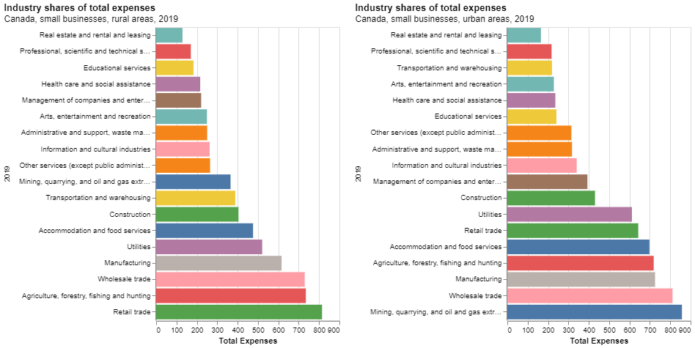

|  |
| --- |

**Financial Ratio**

The current debt to equity is a measure of liquidity, which indicates a firm's relative ability to pay its short-term debts. The lower the positive ratio, the more liquid the business. The debt to equity ratio is a solvency ratio that indicates a firm's ability to pay its long-term debts. The lower the positive ratio, the more solvent the business. We can get the liquidity and solvency of a business based on the two indicators.

**Rural Medium Businesses has higher debt ratio in contrast to urban medium businesses from 2017 to 2019**

From 2017 to 2019, medium businesses in rural areas have a higher current debt to equity in contrast to urban areas. From **Yilin Chart 1,** we can see that the current debt to equity percentage is more than 70% for these years in rural areas while only around 60% in urban areas. It indicates the short term liquidity of rural medium businesses is not good in contrast to urban medium businesses. Also when we look at the debt to equity ratio, the ratio of rural medium businesses is about 1.3 to 1.4, which is higher than the ratio of urban medium businesses. It shows that the long term solvency of rural medium businesses are not as good as urban medium businesses.

And when we look at the debt ratio year by year, we can find that both the current debt to equity and debt to equity ratio for rural medium businesses are growing from 2017 to 2019. The current debt to equity ratio grew from 71.9% to 76% and the debt to equity ratio grew from 1.3 to 1.4. It indicates the debt situation of rural medium businesses are not good in general.

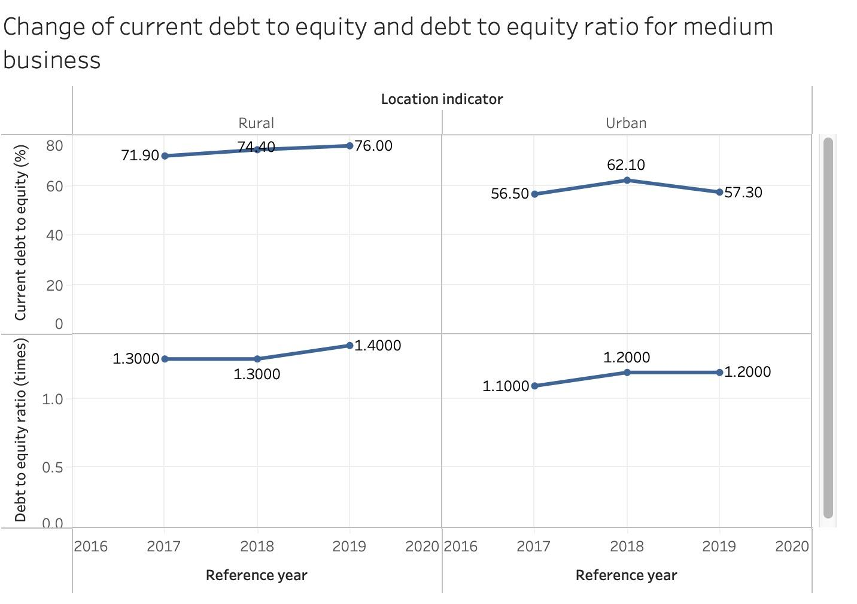

Yilin Chart 1

**Rural Small Businesses has good debt situation in contrast to both urban small businesses and rural medium businesses from 2017 to 2019**

Unlike the rural medium businesses, the rural small businesses perform well from the liquidity perspective in general in contrast to the urban small businesses. When we see the short term situation from **Yilin Chart 2**, we can find that the current debt to equity of rural small businesses is lower than the urban small businesses in 2017 and 2019, the ratio is 44.4% in contrast to 50.7% in 2017 and 43.6% in contrast to 50.9% in 2019. Only in 2018, the ratio is higher in rural than urban, which is 53.7% versus 50.2%. In general, the rural small businesses perform well in short term debt in contrast to the urban small businesses. And we can see that the debt to equity ratio of small businesses are the same in both rural and urban areas from 2017 to 2019. It indicates the situation is quite similar for rural and urban small businesses in long term debt situations.

In addition, the rural small businesses have a better liquidity condition compared to the rural medium businesses. The debt to equity ratio of rural small businesses is 1.2, which is lower than the ratio of rural medium businesses. It indicates the long term solvency of small rural businesses is better in contrast to the medium rural businesses. Also the short term liquidity of small rural businesses are also better. The current debt to equity of rural small businesses are significantly lower in contrast to that of rural medium businesses. In 2019, the ratio is 76% for medium versus 43.6% for small.

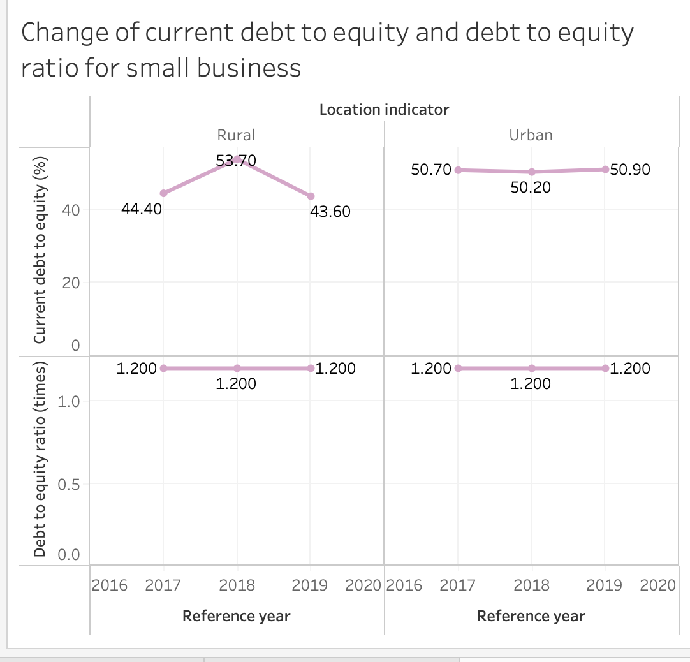

Yilin Chart2

**Medium and Small rural businesses have different industries facing liquidity and solvency problems in 2019**

When we look at the current debt to equity and debt to equity ratio in detail based on industries from **Yilin Chart 3 and Yilin Chart 4**, we can find that medium and small rural businesses have different industries that are facing higher debt ratios.

For the medium rural businesses, the retail trade, professional scientific and technical services, and construction industries have higher current debt to equity in 2019. The ratios are higher than 100% for these industries. And for the debt to equity ratio, the health care and social assistance industry have a significant high ratio, which is higher than 2. That means these industries have a bad solvency from the debt perspective.

We can also know which industries have a good liquidity and solvency from the visualization. The education services, information and cultural industries, and management of companies and enterprises industries have both a lower current debt to equity and debt to equity ratio. That means these industries are in a good condition from the debt perspective.

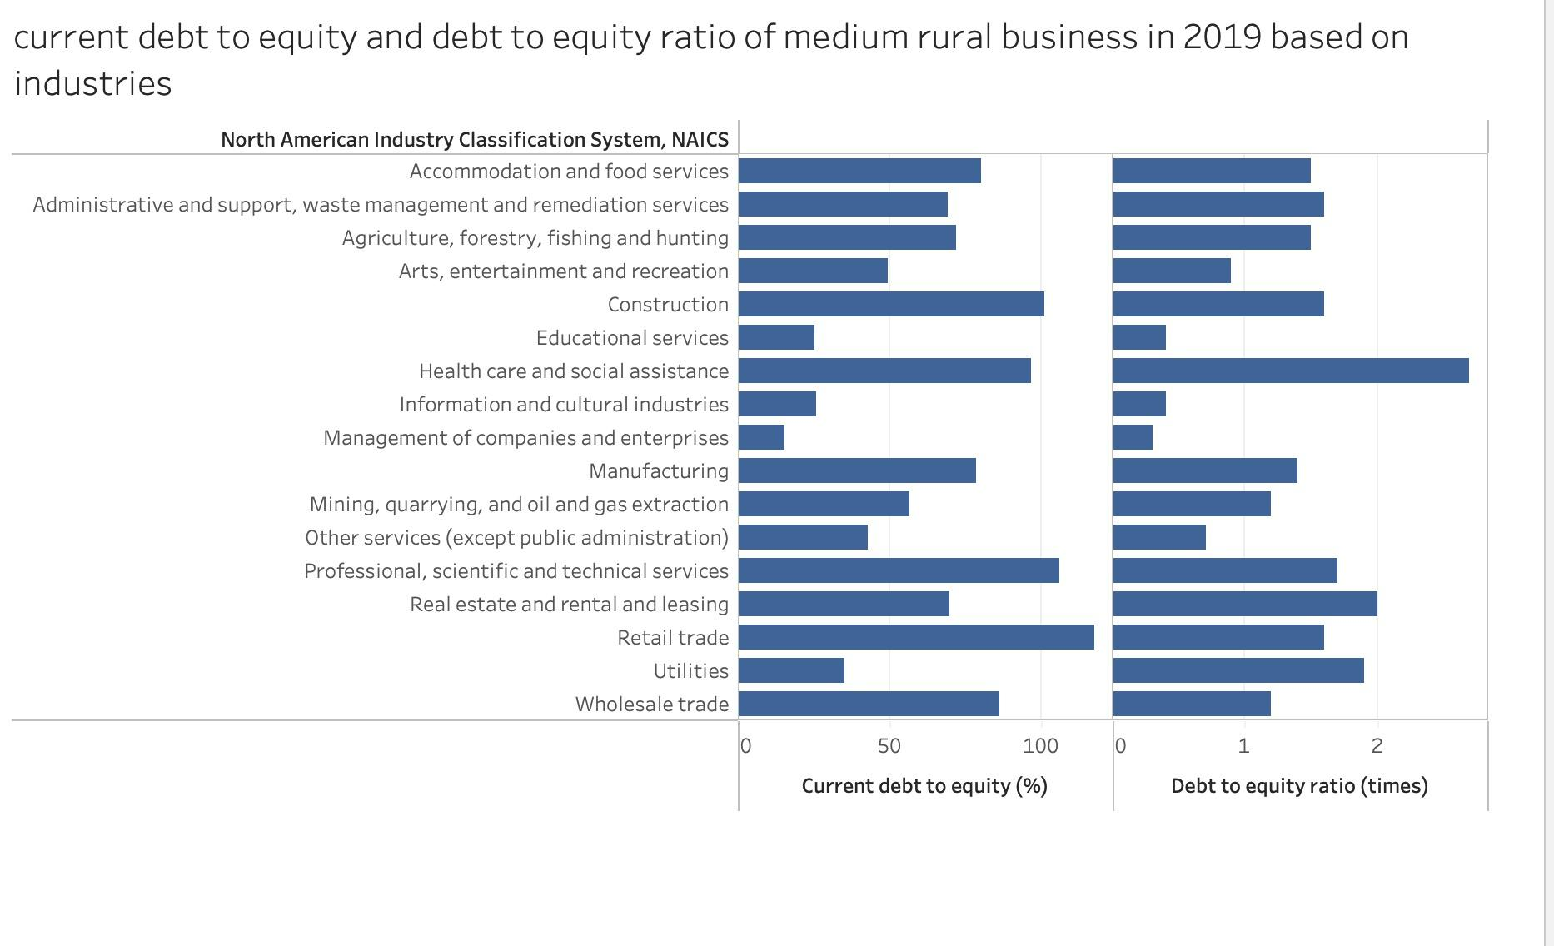

Yilin Chart 3

For the small rural businesses, the short term liquidity is better than the medium rural businesses as no industries have a current debt to equity higher than 100%. But the accommodation and food services, arts entertainment and recreation, and the educational services have higher current debt to equity in 2019. The ratios are higher than 80% for these industries. And for the debt to equity ratio, the accomodation and food services and arts entertainment and recreation have a significant high ratio, which is higher than 2. That means these industries have a bad solvency from the debt perspective in the long term.

In contrast to the medium rural businesses, the health care and social assistance industry have a lower ratio in both current debt to equity and debt to equity ratio for small rural businesses. However the information and cultural industries have a higher ratio in both current debt to equity and debt to equity ratio for small rural businesses compared to that of medium rural businesses. The management of companies and enterprises industries have a lower ratio for small rural businesses, which is similar to that of medium rural businesses.

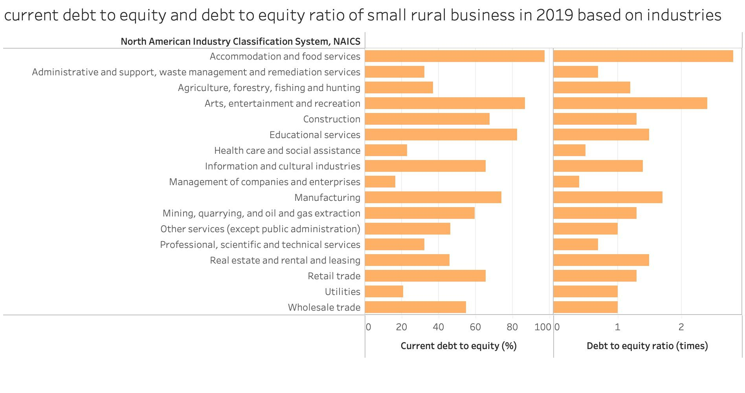

Yilin Chart4

**The net profit to equity ratio of Small Incorporated Business in Rural setting dropped since 2017**

In 2017 to 2018, small incorporated businesses (SIB) in rural areas dropped their average net profit to equity ratio from 16.11% to 15.02%, a 6.8% decrease from the previous year as its average revenue to equity ratio decreased from 1.78 (times) to 1.67 (Chart 1). In 2019, the net profit to equity ratio kept the same level as 2018, which was 15.06%.

In contrast, the SIB in urban areas kept the average net profit to equity ratio around the similar level from 2017 to 2018, which was 15.75% and 15.84%. Nevertheless, the rate dropped to 13.19% in 2019, a 16.73% reduction from the previous year, which was a huge decrease (Chart 2).

The SIB in rural areas had the average net profit to equity ratio of 15.40% from 2017 to 2019 while in urban areas, the average ratio was about 14.93%. Overall, SIB in rural regions have better profitability from 2017 to 2019 since they had higher average net profit to equity ratio.

In terms of the average revenue to equity ratio, the figure of SIB in rural areas was 1.72(times) from 2017 to 2019, while the figure of SIB in urban areas was about 2.16(times), which was 25.63% higher than the rural level. Therefore, SIB in urban areas had better ability to generate cash using the same investment

**Chart 1**

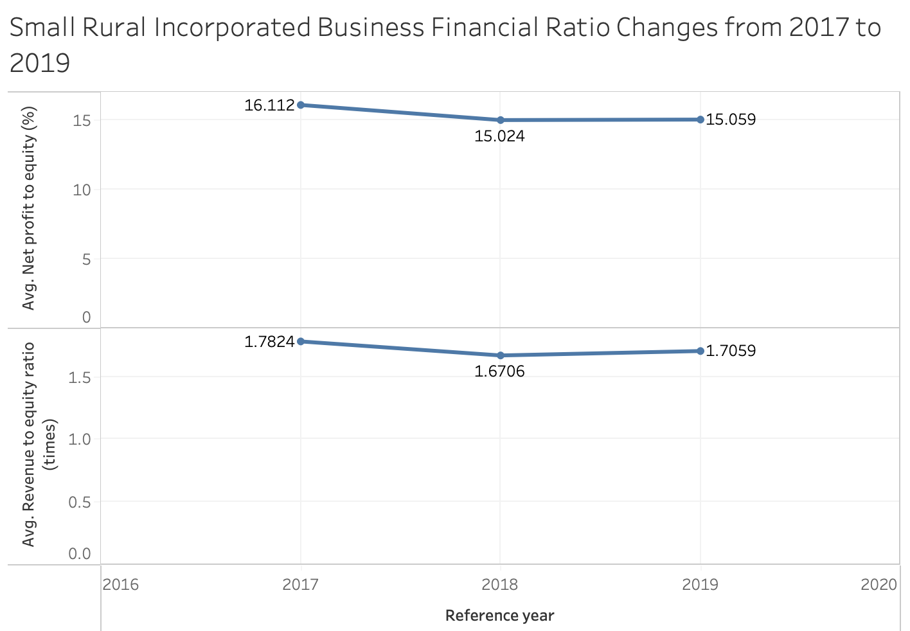

**Chart 2**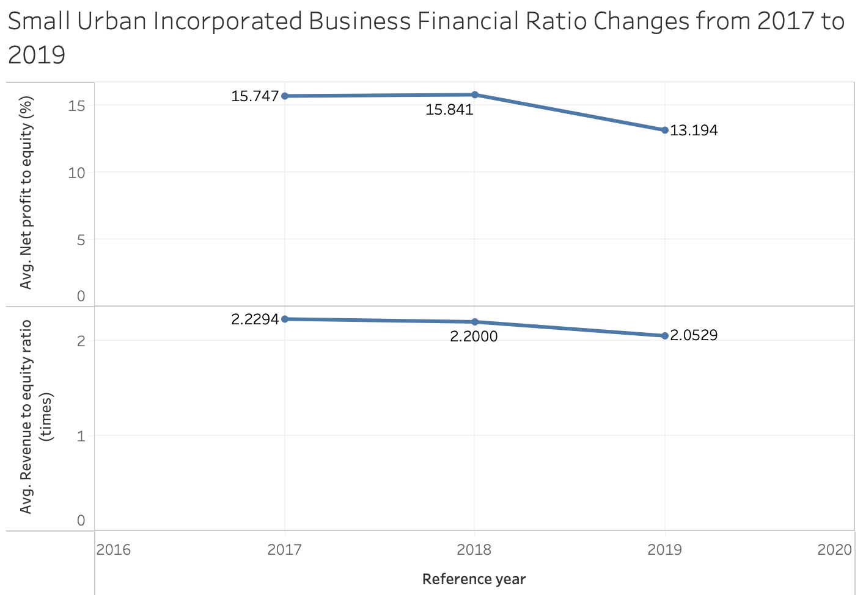

**Unincorporated small businesses in rural regions had better average gross margin rate cross Canada from 2017 to 2019**

From 2017 to 2019, the top three provinces whose incorporated businesses in rural areas had the highest gross margin rate were Alberta, Saskatchewan and Nunavut, which were 71.99%, 71.91% and 67.47% respectively (Chart 3), while for the unincorporated businesses, the top three provinces were British Columbia, Alberta and Saskatchewan, whose average gross margin rate were 77.46%,75.61% and 74.93% respectively (Chart 4). Overall, small businesses that were unincorporated in rural areas had better ability to generate gross profit.

For the incorporated small businesses in rural areas, the most of average gross margin rates from 2017 to 2019 were around 60% to 70% across Canada. However, the figure for Yukon was only 47.15%, which was much lower than other provinces (Chart 3).

For the unincorporated small businesses in rural areas, the average gross margin ratio of three territories in Canada had an apparent gap between the other provinces. The highest average gross margin rate of three territories was 51.52% while the lowest figure for the mainland provinces was 63.43% (Chat 4). The gap was around 12%.

Chart 3

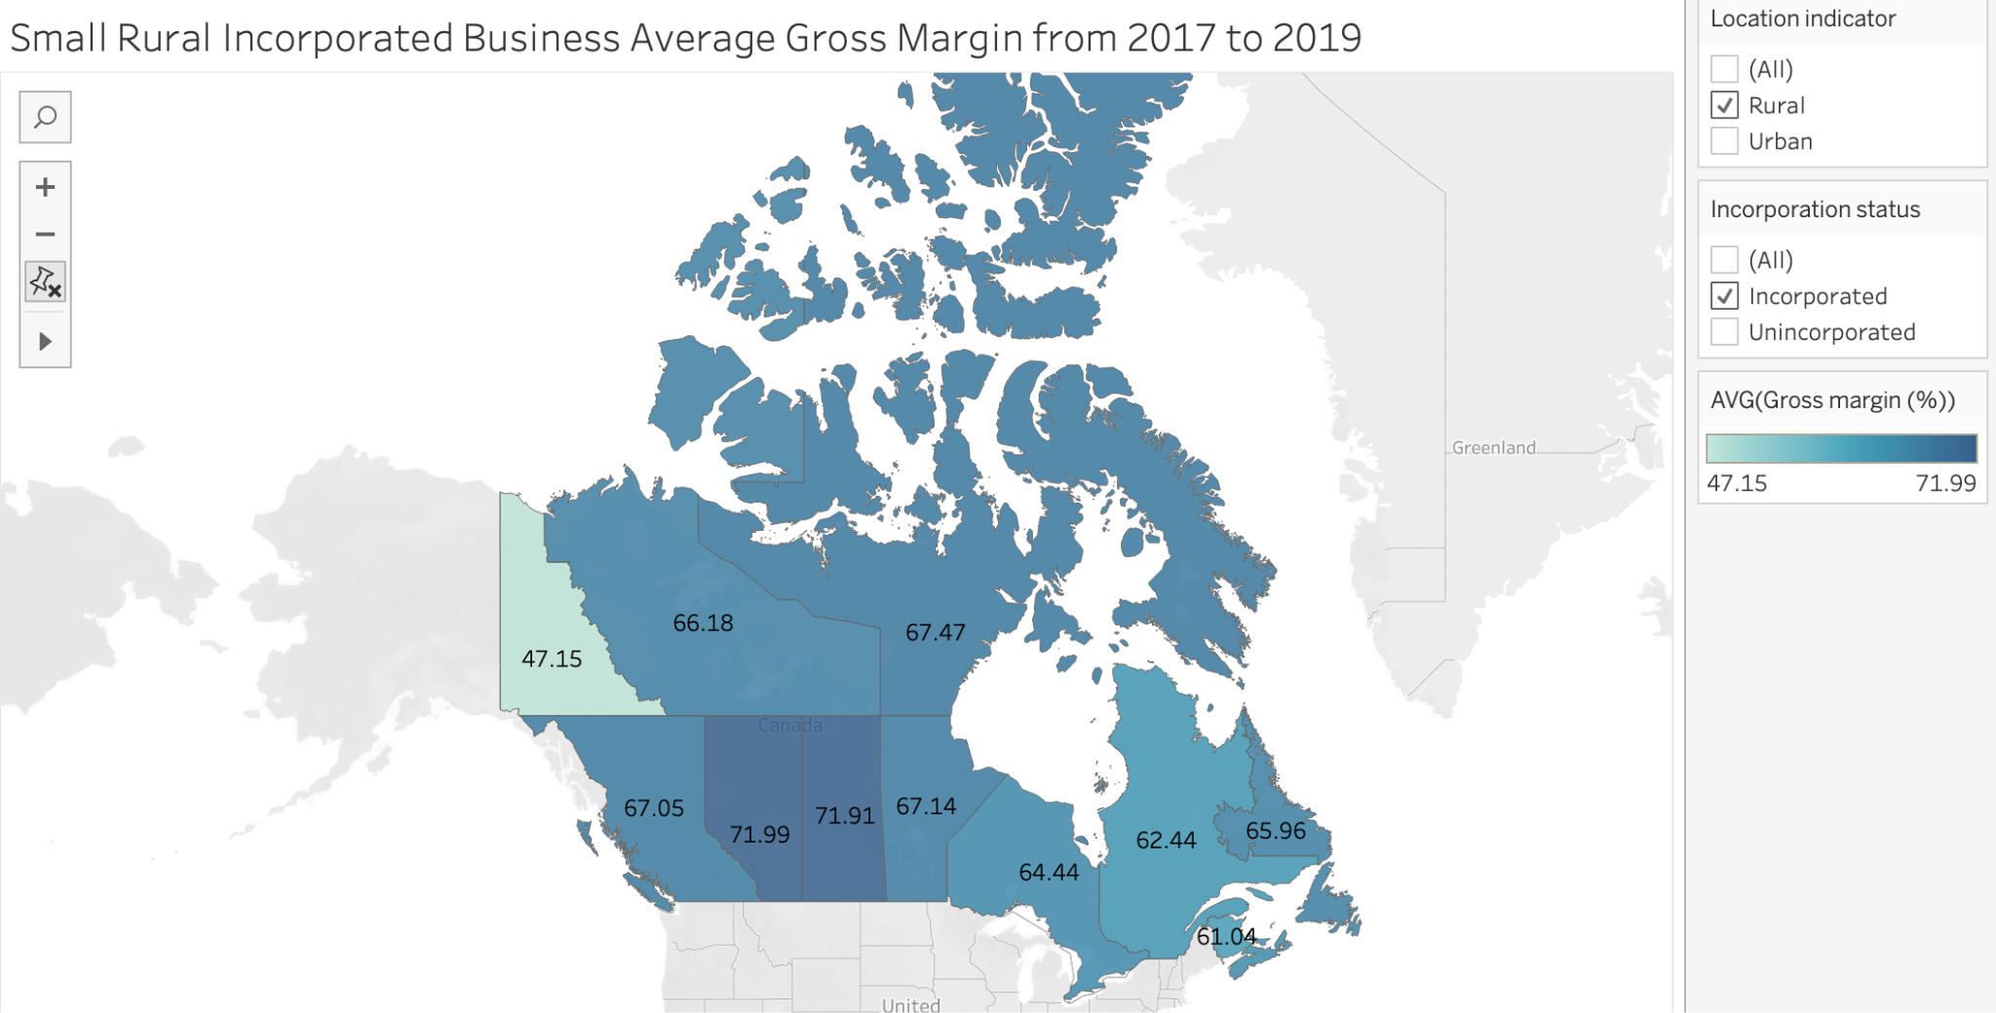

Chart 4

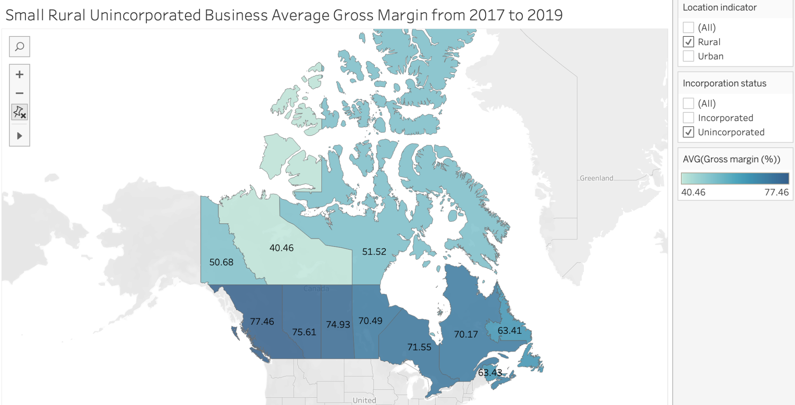

**Medium Incorporated Businesses in rural regions had a better net profit to equity ratio than small incorporated Businesses**

From 2017 to 2019, the medium businesses that were incorporated in rural areas had a steady average net profit to equity ratio, which were 20.42%, 22.35% and 21.48% respectively. In general, the figures had increased since 2017 by 7%.

For the small businesses, the average net profit to equity ratio decreased from 16.11% to 15.09% during the same period, which was about 5% lower than the medium businesses in each year (Chart 5). Medium businesses in rural areas could generate more money when utilizing the same amount of investment.

**Chart 5**

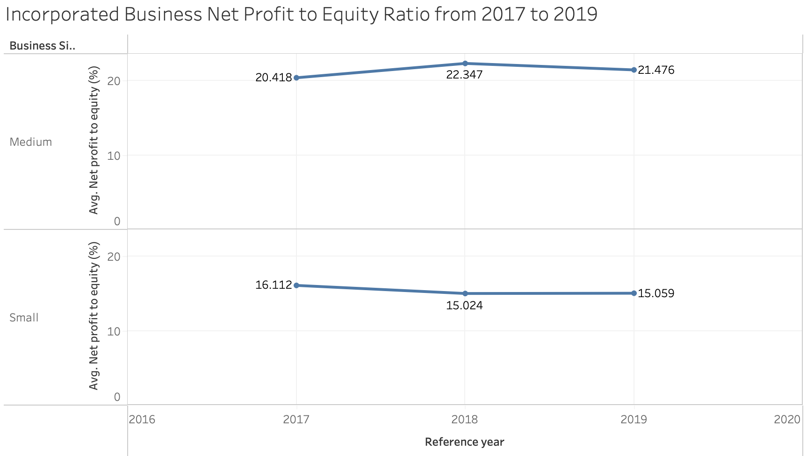

**The industries of Medium Incorporated Businesses in Rural areas who had higher gross margin rate had lower net profit to equity ratio**

From 2017 to 2019, the top three industries who had the highest average gross margin rate of the incorporated medium business in rural areas were Education Services, Agricultural,Forestry,Fishing and Hunting, and Health Care and Social Assistance, whose figures were 94.83%, 81.2%, 79.4% respectively. This may result from the lower cost of sales since all of these three industries belong to the service industry. However, the average net profit to equity ratio of the Agricultural,Forestry,Fishing and Hunting industry from 2017 to 2019 was -22.5%, which was the lowest one among all industries (Chart 6).

The top three industries who had the highest net profit to equity ratio of the incorporated medium business in rural areas were Professional, Scientific and Technical Services, Construction and Health Care and Social Assistance, whose figures were 78.4%, 39.6% and 34.5% respectively (Chart 6). It indicates that for the same amount of investment, these three industries could generate more money than others in Canada.

**Chart 6**

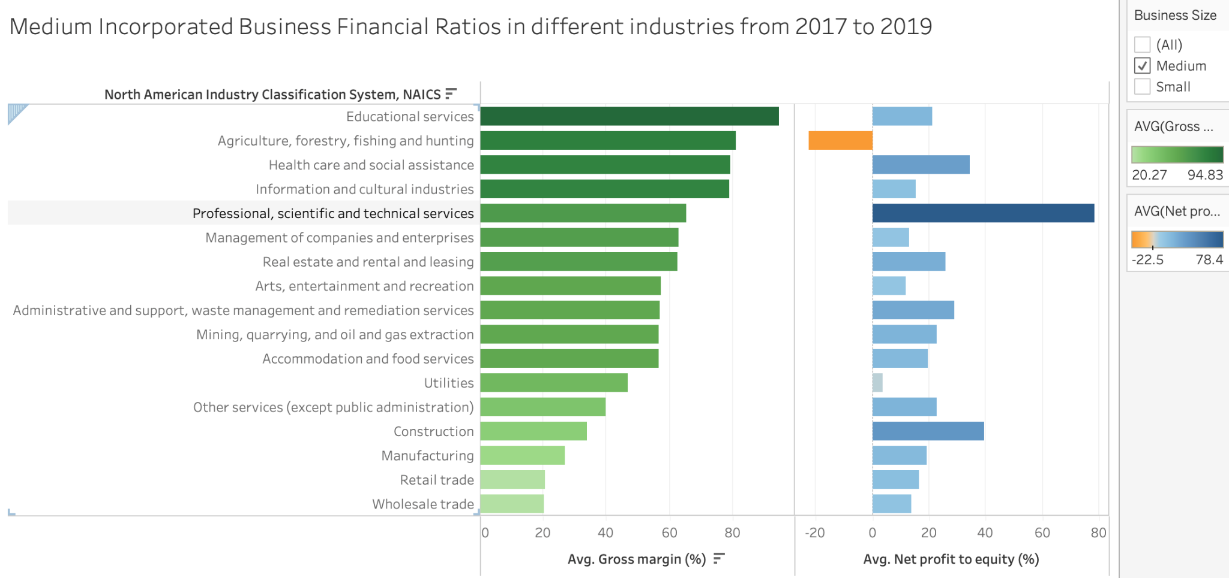

**Small Incorporate Businesses in rural had relatively similar average net profit to equity ratio among all industries from 2017 to 2019**

From 2017 to 2019, the top three industries who had the highest average gross margin rate of the small incorporated business in rural areas were Agricultural,Forestry,Fishing and Hunting, Health Care and Social Assistance and Management of companies and enterprises, whose figure were 95.17%, 92.8%, 84.27% respectively. These numbers were close to the medium incorporated businesses in rural areas. In the same situation, small rural businesses in the Agricultural,Forestry,Fishing and Hunting industry lost money since its average net profit to equity ratio from 2017 to 2018 was -10.53%. Although it was still negative, it was better than the medium incorporated businesses in rural areas (Chat 7).

The top three industries who had the highest net profit to equity ratio of the incorporated small business in rural areas were Education Services, Health Care and Social Assistance, and Professional, Scientific and Technical Services, whose figures were 34.63%, 31.83% and 29.1% respectively (Chart 7). However the average net profit of equity ratio between small rural and medium rural businesses in Professional, Scientific and Technical Services had a huge gap, which is around 36%.

**Chart 7**

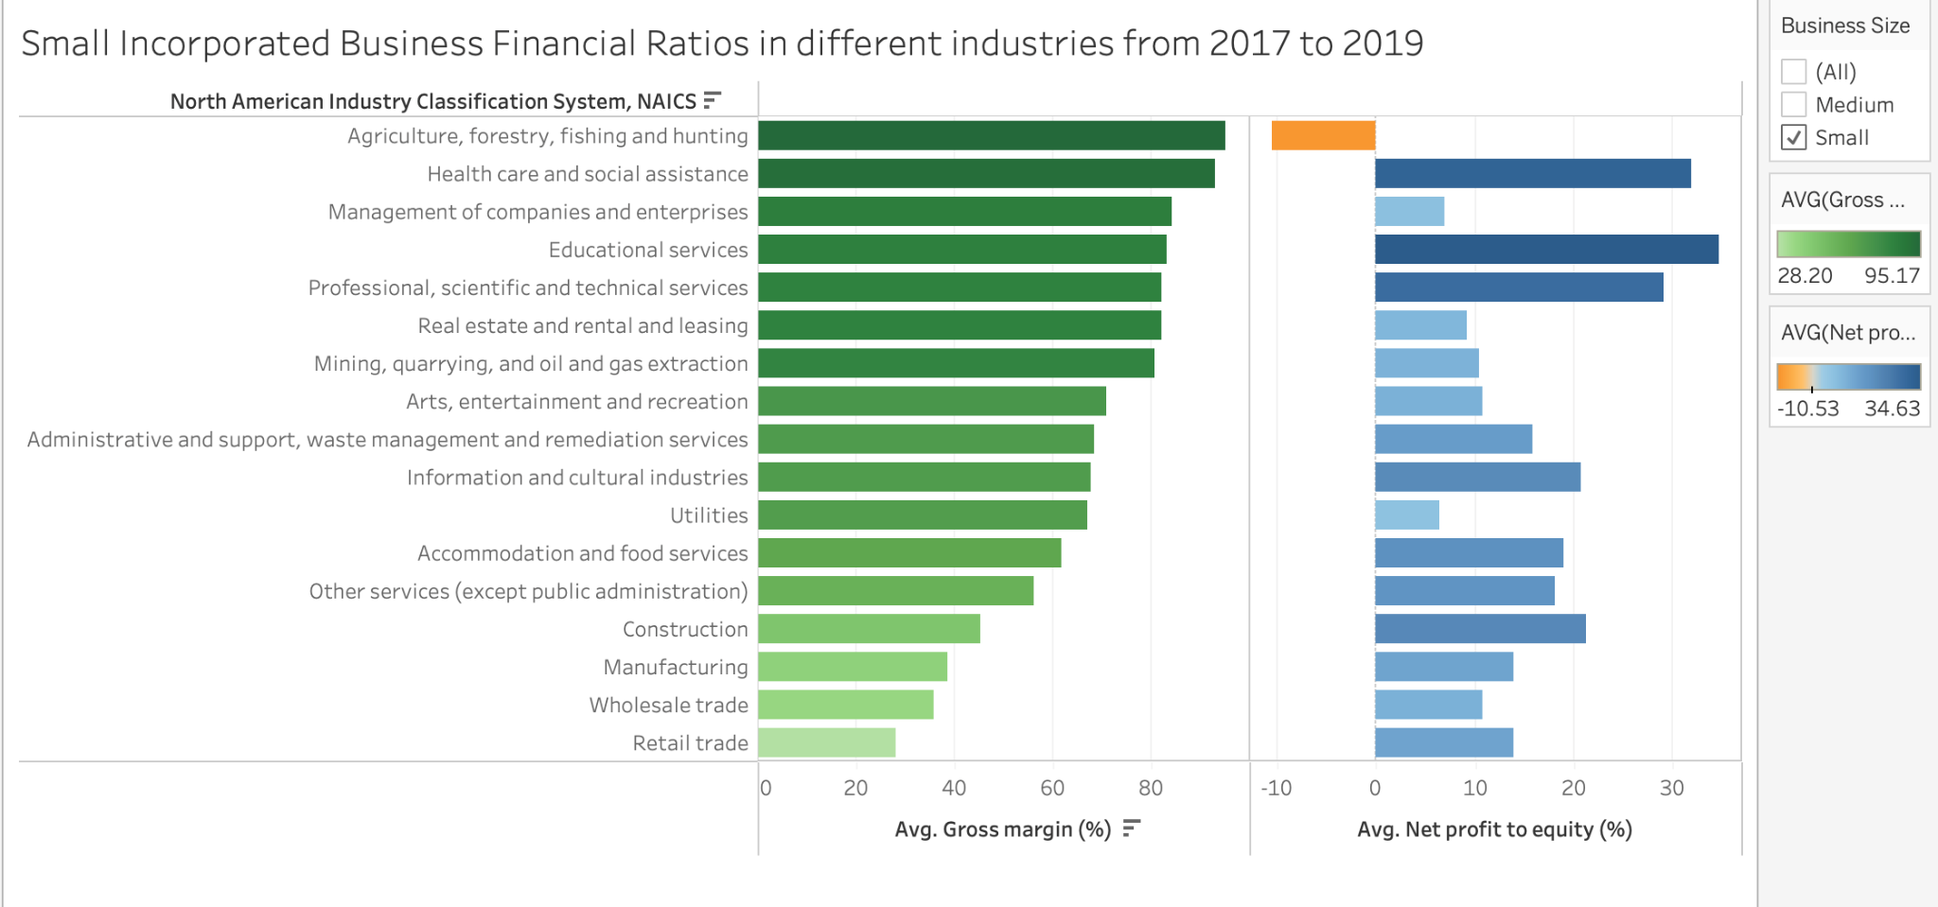

**References**

Statistic Canada. 2022. “Population growth in Canada's rural areas, 2016 to 2021.” Statistics Canada. https://www12.statcan.gc.ca/census-recensement/2021/as-sa/98-200-x/2021002/98-200-x2021002-eng.cfm.

Khodja, Mahdia, Eric Baxter, and Haaris Jafri. 2022. “Rural and Small Town Canada Analysis Bulletin A profile of businesses in rural Canada, 2017 to 2019.” Statistic Canada. https://www150.statcan.gc.ca/n1/pub/21-006-x/21-006-x2022003-eng.htm.

Statistics Canada. 2022. “Statistic Canada.” Rural Canada statistics. https://www.statcan.gc.ca/en/subjects-start/society_and_community/rural_canada.

1. “Population Growth in Canadas’ rural areas, 2016 to 2021”,Statistic Canada,https://www12.statcan.gc.ca/census-recensement/2021/as-sa/98-200-x/2021002/98-200-x2021002-eng.cfm
2. “Population Growth in Canadas’ rural areas, 2016 to 2021”,Statistic Canada,https://www12.statcan.gc.ca/census-recensement/2021/as-sa/98-200-x/2021002/98-200-x2021002-eng.cfm
3. “A profile of businesses in rural Canada, 2017 to 2019.”,Statistics Canada, https://www150.statcan.gc.ca/n1/pub/21-006-x/21-006-x2022003-eng.htm
4. “Rural Canada Business Profiles Database 2017-2019 Metadata and user guide.” Statistic Canada. https://www150.statcan.gc.ca/n1/pub/45-20-0004/452000042022001-eng.htm